Lab 6.3 Using ConfigMap

1. Create a configmap-definition.yml file as below:

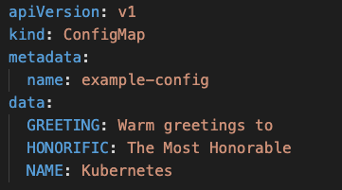

1. Create the configmap

**kubectl create -f configmap-definition.yml**

1. Check the configmap

**kubectl get configmap**

**kubectl describe configmap**

1. **Create a pod-definition.yml file as below**

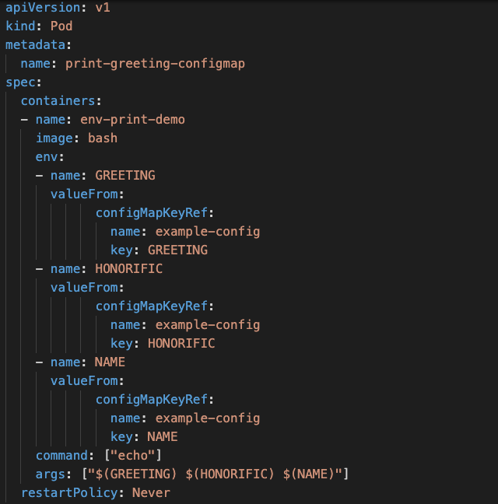

1. Create the pod

**kubectl create -f pod-definition.yml**

1. Check the Logs

**kubectl logs -f print-greeting-configmap**